Mullings
An American Cyber-Column
Willful Neglect
Rich Galen
Monday, March 7, 2016
- I was on Al Sharpton’s MSNBC Sunday morning program yesterday &#133;
Dear Mr. Mullings:
<blockquote><i>Why in the world would you get up at six on a Sunday morning to appear on a program with Al Sharpton that maybe 10 people were watching?
Signed,
Everybody</i>
Because I have an ego the size of Wyoming.</blockquote>
- &#133; and, of course, Sharpton wanted to make the Republicans the bad guys and the Democrats the good guys.
- I get along fine with Al Sharpton, so I explained to him that while the media is totally focused on the Donald Trump phenomenon, the exact same thing is happening on the Democrat side. That is why Bernie Sanders is still in that race and raised over $40 million in small donations in February alone.
- Absent Clinton’s vast lead in unelected Super Delegates, Sanders only trails her by 159 delegates. The Super Delegates do count, of course, but it makes my point that Mr. and Mrs. <i>Democrat</i> A.A. are not falling over themselves to vote for the senior establishment candidate in this race, Hillary Clinton.
- The answer is this. I live just inside the Washington Beltway. I can see it from my back porch – or would be able to see it if other townhouses weren’t in the way.
- My office is flat in the middle of downtown DC. About six blocks from the White House.
- I see, email, retweet, and talk to other political people, Republicans and Democrats, all day; every day.
- We see each other at lunch, at receptions, at dinners (such as last night’s Gridiron Dinner), in Green Rooms and at the grocery store.
- We don’t see almost anyone who does not live in or near Washington, DC unless they are (a) a client, (b) very wealthy or (c) both.
- When we see and talk to one another we often disagree on what the outcome of a policy fight or a political campaign will be, but we absolutely agree on the rules of disagreement.
- We are not enemies. We are political opponents.
- Not only that, but we agree that the stuff we talk about is to Mr. and Ms. Average American as quantum physics is to me. I may know the words, but I have no idea what they mean.
- Quantum physicists are correct about my not understanding. Must of the political geniuses in Washington are wrong about Mr. and Mrs. Average American. They do understand what’s going on and they know that whatever is going on ain’t working in their favor.
- In fact, they believe – Republicans <i>and</i> Democrats – are actively plotting against them and, they may be right. I don’t plot against anyone if only because I’m not smart enough to plot anything and not get caught doing it.
- Same thing with our friends on the other end of the Axis of Inaction, New Yorkers.
- Too many people who live and work in or near Manhattan and see still see the world the way satirist Saul Steinberg drew for this famous New Yorker cover published on March 29, 1976.
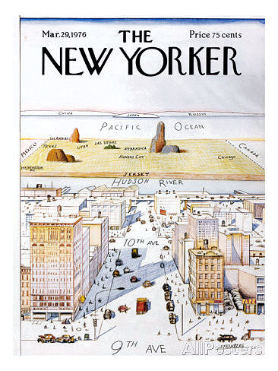
- They don’t have the slightest idea what is going on at the kitchen tables of Mr. and Mrs. AA anywhere west of the Hudson River. And they don’t want to know.
- I spent more time, effort, planning, and money flying to Budapest to investigate the plight of the refugees pouring into Europe than I have on the water crisis in Flint, Michigan – which has been zero, I’m mortified to admit.
- I have a theory that my interest in someone else’s problems decreases by the square of the distance between me and them.
- And that goes for everyone.
- Flooding in St. Louis? Don’t live next to a river. Drought in California? Stop growing almonds. Earthquake in China? Quit constructing crap buildings.
- Now, we’ve been found out. And, not only have we been found out but voters on both sides have found a way to let us know that they know: They’re voting for Donald Trump and Bernie Sanders.
- Trump is likely to be the GOP’s nominee. Sanders is not likely to gain that prize for the Dems.
- But, if we in the Axis of Inaction don’t learn the lesson this time, there may be a much higher price to pay than losing an election.
- I plead guilty to willfully neglecting the needs, the dreams, and the aspirations of Mr. and Mrs. Average American. I will try to get better at taking a serious interest in them.
- On the <a href = “http://www.mullings.com/dr_03-07-16.htm”> <b>Secret Decoder Ring</b></a> page today: Links to the Steinberg magazine cover, to Almonds in California, to an explanation of quantum physics, and to the Bloomberg delegate tracker.
The Mullfoto is a license plate on a car in a parking garage in Old Town Alexandria Virginia over the weekend.

-- END --

